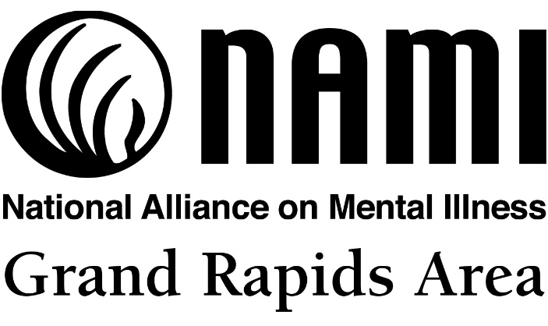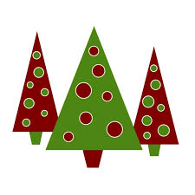
Holiday Gift Drive
Mon Nov 27th – Fri. Dec 15th
Gift Drop Off: MacRostie Art Center YMCA
Pickled Loon Country Kitchen
Public Library Brewed Awakenings
Rapids Brewing MJ’s in Pengilly
North Homes First Call for Help
Grand Itasca Clinic/Hospital Employees

Sadly, many individuals hospitalized for mental illnesses during the holidays do not get visitors or gifts. Help us brighten the Holiday Season for those hospitalized at Fairview Range Medical Center in Hibbing (34 patients), New Leaf Healing Center (6 patients), and North Homes (Cash donation - 64 youth).

Gifts must be new, unwrapped and safe (nothing sharp or breakable, no ribbons or strings). Ideas: stamps, art materials, games, puzzles, air dry clay, DVDs, origami paper, journals (non-spiral), stationary, scrapbooking supplies, crossword puzzles, word finds, Sudoku, books, magazines, playing cards, cookbooks, gift cards (bus fares, groceries, home goods), stress ball, scarves, gloves, t-shirts, nice soaps, toiletries, calendars, microwave popcorn, gum, etc.

To Donate Cash:
- Send a check (NAMI Grand Rapids Area) to P.O. Box 203, Grand Rapids, MN 55744
- For Credit Card, Paypal, Venmo – email Mark at gr.mn.nami@gmail.com

Thank you! www.namigrandrapidsmn.org

